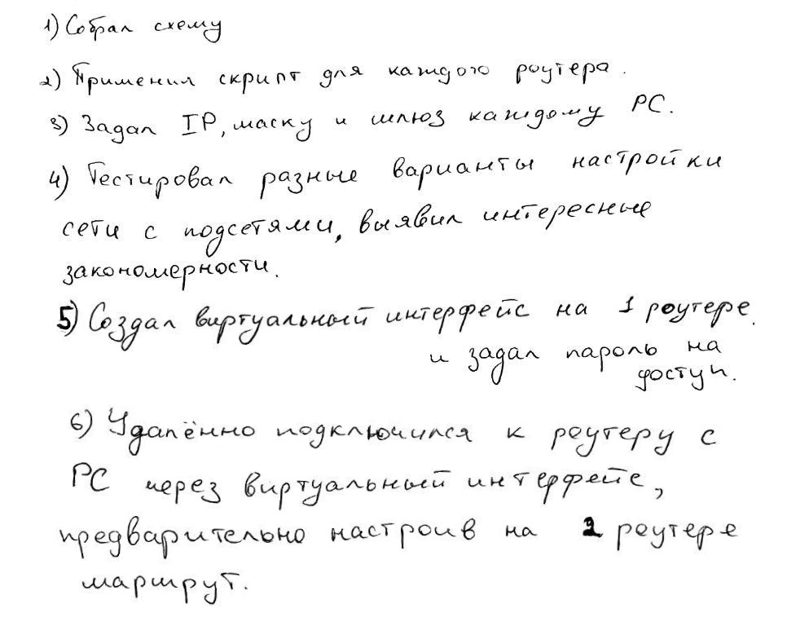

en

conf t

int f0/0

ip address 172.16.1.2 255.255.255.0

no shutdown

int s2/0

ip address 172.16.61.1 255.255.255.0

clock rate 1200

no shutdown

int s3/0

ip address 172.16.12.1 255.255.255.0

clock rate 1200

no shutdown

end

number = 6  
  
target1 = str('{0}{1}.{1}'.format(number, (number) % 6 + 1))  
target2 = str('{1}{0}.{1}'.format(number, (number - 2) % 6 + 1))  
print('en\nconf t')  
  
print(  
f"int f0/0\n\  
ip address 172.16.{number}.2 255.255.255.0\n\  
no shutdown\n\  
int s2/0\n\  
ip address 172.16.{target1.split('.')[0]}.{number} 255.255.255.0\n\  
clock rate 1200\n\  
no shutdown\n\  
int s3/0\n\  
ip address 172.16.{target2.split('.')[0]}.{number} 255.255.255.0\n\  
clock rate 1200\n\  
no shutdown\n\  
end\n\  
"  
)  
print('en\nconf t')  
  
  
arr = [x for x in range(1, 7)]  
  
  
counter = 0  
pos = number  
while arr[(pos + 1) % 6] != number:  
 if counter >= 2:  
 print(f'ip route 172.16.{arr[pos % 6]}{arr[(pos + 1) % 6]}.0 255.255.255.0 172.16.{arr[(number - 2) % 6]}{arr[(number - 1) % 6]}.{arr[(number - 2) % 6]}')  
 else:  
 print(f'ip route 172.16.{arr[pos % 6]}{arr[(pos + 1) % 6]}.0 255.255.255.0 172.16.{arr[(number - 1) % 6]}{arr[(number) % 6]}.{arr[(number) % 6]}')  
 pos += 1  
 counter += 1  
  
  
pos = number - 1  
counter = 1  
while counter <= 3:  
 print(f'ip route 172.16.{arr[(pos - counter) % 6]}.0 255.255.255.0 172.16.{arr[(number - 2) % 6]}{arr[(number - 1) % 6]}.{arr[(number - 2) % 6]}')  
 print(f'ip route 172.16.{arr[(pos + counter) % 6]}.0 255.255.255.0 172.16.{arr[(number - 1) % 6]}{arr[(number) % 6]}.{arr[(number) % 6]}')  
 counter += 1

en

conf t

int loopback 0

ip address 172.16.100.1 255.255.255.0

end

en

conf t

line vty 0 15

password 123

end

en

conf t

ip route 172.16.100.0 255.255.255.0 172.16.12.1

end

# Приложение

